March 2018

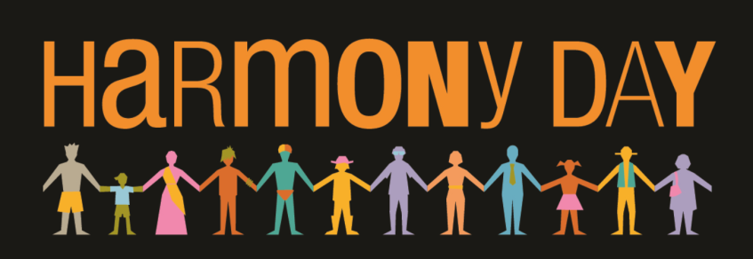

Harmony Day at Denistone East Public School

On Wednesday 21 March 2018 we will be celebrating Harmony Day.

Harmony Day is a day of cultural respect for everyone who calls Australia home – from the traditional owners of this land to those who have come from many countries around the world.
We would like students to dress in their National costume, or in that of their favourite country, or orange clothing to help celebrate our diversity.

We will be participating in Harmony Day activities, so we can learn and understand how all Australians from diverse backgrounds equally belong to this nation and enrich it.
Read more at https://www.harmony.gov.au/

Principal (Acting)
Michelle Collyer

